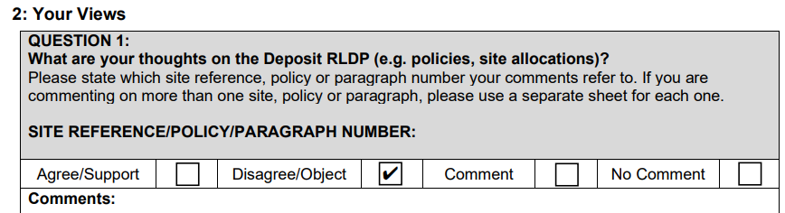
Opposition views for document Vale of Glamorgan Council Replacement Local Development Plan 2021 – 2036
To summarise, the proposed development contradicts many of the stated objectives within the Deposit Plan and would have significant negative impacts on the community of Dinas Powys. Existing infrastructure, including roads, schools, healthcare services and drainage systems, is already under considerable strain, and further large-scale housing would worsen congestion, increase flood risk, and place unsustainable pressure on local services. The loss of valuable green space would damage local wildlife habitats, reduce opportunities for recreation and wellbeing, and undermine the rural character of the area. Rather than supporting sustainable, resilient communities, this development risks harming the environment, weakening community cohesion, and failing to meet the needs of both current and future generations.
Page 5: ‘The Vale has a skilled and adaptable workforce’ which ‘has enabled existing business to grow and thrive and has contributed to a reduction in outward commuting’.
As a resident that regularly commutes to a local school for work and the surrounding areas of Penarth, Barry and Llandough, I would highly disagree with this statement. The traffic throughout Dinas is continually and regularly heavy and at times gridlocked, especially with the fact that Cardiff road is the only means of travel in and out of Dinas. The proposed entrance site at the point alone will severely impact this detrimentally.

Page 5: ‘Through investment in active travel, public transport, and broadband connectivity the rural vale is a living and working countryside supporting a network of sustainable and thriving rural communities’.
The train station at Eastbrook is only fully accessible to those able bodied members of the community. The station is accessed only via steps to each side of the track. Investment has not been undertaken despite it being flagged by the community.
The notion of a ‘rural community’ will be no longer valid if the development goes ahead. The status of village for Dinas will be greatly diluted with the minimisation of the boundary with Llandough.
Removal of green space, along with the destruction of forests for building materials, is in direct contradiction of the terms ‘countryside’, ‘rural’, ‘sustainable’ and ‘thriving’ in any and all senses. This is before the consideration of the impact of flooding in the area which has already been seen within Dinas due to the imbalance of the water table owing to building on green space. More than 100 homes along Cardiff road experienced catastrophic flooding in December 2020. This is also in contradiction to the statement that ‘Places are safe, accessible and socially inclusive’. Many residents had to leave their homes with some elderly members sadly did not live long enough to return.
National resources Wales have been investigating the floods that occur within Dinas and have prepared a flood management scheme. This explores risks to flooding and plans to prevent future floods and in no way suggests that additional builds are a positive move to reducing further risk. In fact this is quite the opposite, with national resources Wales not being in agreement with the planned development. In fact, they detail a long term vision that includes ways to ‘protect, enhance and value the environment’, as well as ‘improve the resilience and quality of ecosystems’.

Objective 1: ‘Ensure that all new development and infrastructure is resilient to future impacts arising from Climate Change’.
Removal of green space will further impact the water table and will, again, ultimately affect the environment of the local area. Flooding is already a problem within Dinas, and this will add further negative impact. Not only will this impact homes, but wildlife. Surface drainage systems at present cannot cope with heavy rainfall, and floods occur with heavy rainfall. Further reduction of the water table will only serve to exacerbate this problem where water will have no choice but to drain to the lower areas of Cardiff road and surrounding fields with wildlife and farm animals. This has already been seen as a result of the recent build at the top of Murch Road, where the pedestrian lane through to Sully Road floods with just average rainfall, along with Sully road itself as a consequence. Waste pipe systems beneath Cardiff Road from existing homes are not without fault, with sink holes already discovered as a result within Chapel Close, heavily impacted by the drainage of excess surface water during rainfall. This problem has been looked at by Dwr Cymru on more than one occasion, the most recent being late 2023.
Taken from Natural resources Wales): “Green space also helps to keep towns and cities cool during heat waves. It helps to filter pollution from the air, reduces stress and promotes mental health and wellbeing”. The green space is needed to combat the effects of climate change. Removal of it will be not only reducing the ability of minimising this impact, it will actively be adding to it.

Page 5: ‘Development respects local character and contributes positively towards health and well-being’
Accessible green space respects local character and contributes positively towards health and well-being, not additional buildings that result in pollution, congestion, oversubscribed schools and healthcare.
Removal of green space will have a detrimental effect on those already resident within the community.
Taken from Natural resources Wales): Green space stimulates children to do better at school (Ref Children Nature Network)”, with ‘the provision of quality, accessible, local green space is critical in improving our health as a nation’”. Dinas has already seen increasing numbers of houses on a large scale and the impact is already apparent. Flooding, competition for schools and healthcare, increased congestion, inadequate roads for commute demands, poor road quality, reduction in the feel of a community, loss of wildlife, loss of green space. As well as generations that are displaying the effects of lockdown on their mental health and wellbeing, that need our support to thrive. This development will not provide that support. No part of these plans take into account our current and future generations. They only add challenges that will damage the community which they call home.

Post lockdown, many adults and children alike are struggling with mental health concerns as a result of time spent in isolation. This is becoming more and more apparent within school settings, and is apparent in schools within the community of Dinas. Knowing that children within the community use Seal park and the surrounding green space as a safe and private space for playing, exercising and socialising, changes in this will have a detrimental impact on this time and ultimately on their health and wellbeing. In addition to this the competition of school spaces will be massive, which will reduce what it means to feel part of a community, force families to travel to gain education, impacting congestion on the roads and family/work life balance, and reduce potential of building social bonds of children and families within the community. In accordance with the Future Generations Wellbeing Act 2015, and Act unique to Wales, huge impacts such as these should not be overlooked.

Objective 5: ‘Prioritising previously developed brownfield land for new development, directing development away from areas of nature conservation interest and safeguarding the sensitive natural environment from inappropriate development’.
The development in question is in complete contradiction to this claim. The build is inappropriate. There is no need for further housing within a community that cannot sustain it, in terms of schools, healthcare, and travel systems. In terms of the environment, there are many protected species of plant and wildlife that inhabit the green space in question. Wildflowers such as bluebells, bats and birds of prey thrive within the environment concerned. These are well known as commonplace within the area by local residents. “Given the available habitat (the river corridor through Dinas Powys) there’s potential for protected and notable species to be present, including: Bats, Otters, Reptiles, Amphibians, Nesting Birds (kingfisher is of particular interest as they usually nest within high riverbanks” (Taken from Natural resources Wales). These species are protected by law and specifically the Wildlife and Countryside Act 1981 which concerns the protection of bats. Bats will be negatively affected by the loss of their habitats, introduction of new buildings, as well as simply the addition of lighting. The proposed build will bring these in abundance and so will be highly detrimental to their survival.

Page 5: ‘Positive improvements have been achieved for residents living in the most deprived areas through improved access to employment, education, training, services, and investment in the built environment’.
Schools are currently at a maximum capacity. St Cyres alone received over 500 applications for pupils transitioning to secondary school this year, which is double its intake capacity. New residents will not be able to benefit from this proposed development as there simply is not enough space to accommodate, rendering this statement false. The only investment is in houses, which is not an investment to the environment. No additional schools, healthcare or travel systems have been included. Therefore, no further jobs have been created and so no positive improvements as the statement aims to promise.
Increasing the number of houses will result in increased strain on schools, increase pressure of families currently residing in Dinas in concerns over admissions for schools, and force children to travel further for education. This in turn will have negative effects on families by causing additional stress through further commute; earlier waking and leaving times; increased commute times; disjointed locality of friendship groups; reduction in community feel for pupils and young families as a whole; contributing in turn to poor community bonds and support and consequently well-being and mental health; as well as adding to the congestion within Dinas and surrounding areas. Additional congestion will also bring with it increased detrimental effects on the local and surrounding environment of car exhaust fumes.
In conclusion, the proposed development contradicts many of the stated objectives within the Deposit Plan and would have significant negative impacts on the community of Dinas Powys. Existing infrastructure, including roads, schools, healthcare services and drainage systems, is already under considerable strain, and further large-scale housing would worsen congestion, increase flood risk, and place unsustainable pressure on local services. The loss of valuable green space would damage local wildlife habitats, reduce opportunities for recreation and wellbeing, and undermine the rural character of the area. Rather than supporting sustainable, resilient communities, this development risks harming the environment, weakening community cohesion, and failing to meet the needs of both current and future generations.

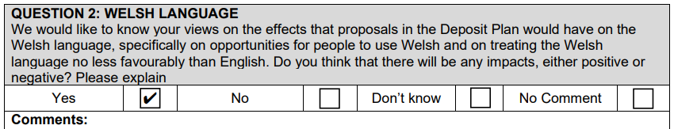
The proposed scale of housing, without adequate provision for schools, healthcare, and community infrastructure, risks placing significant pressure on existing services and the Welsh-speaking community. This in turn, would reduce opportunities to access Welsh medium education (no additional capacity offered) and to use Welsh in everyday life. As such, the proposal may have a negative impact on the Welsh language and does not demonstrate how Welsh will be treated no less favourably than English.

- Pressure on Welsh-medium education
Local schools are already at or near capacity. Additional housing without new school provision will increase pupil numbers significantly. This could reduce availability of places in Welsh-medium schools or Welsh-language streams, limiting opportunities for children to be educated through Welsh.
If Welsh-speaking pupils cannot access Welsh-medium education locally, this undermines efforts to treat Welsh no less favourably than English.
- In-migration that may dilute the Welsh-speaking community
Large housing developments often attract buyers from outside the area. If the majority of new residents are non-Welsh speakers, the proportion of Welsh speakers locally may decline. A reduced concentration of Welsh speakers can weaken everyday use of the language in community settings such as schools, shops, and local activities.
3 Strain on community services where Welsh is used
GP surgeries, community centres, and other public services already face capacity issues. Increased demand may reduce the ability of services to provide Welsh-language provision, especially if staffing pressures increase. Residents may find it harder to access services through Welsh.
4. Impact on community cohesion and language use
Welsh thrives where it is used naturally in the community. Rapid expansion without supporting infrastructure can disrupt existing social networks and community identity. This may reduce informal opportunities to use Welsh in daily life.
5. Lack of supporting Welsh-language measures
The proposal appears to include no clear strategy to protect or promote Welsh, such as: support for Welsh-medium school capacity; community facilities encouraging Welsh use; measures to integrate new residents into the Welsh-speaking community.

