Landscape Setting, Conservation Area Context, Special Landscape Area Protection, Flood Influenced Development Pattern and Policy Conflict

Landscape Setting of Aberthin and the Conservation Area
The settlement of Aberthin occupies a distinctive landscape position within the Nant Aberthin valley. The importance of this setting is explicitly recognised in the Aberthin Conservation Area Appraisal and Management Plan, adopted by Vale of Glamorgan Council as Supplementary Planning Guidance and forming a material planning consideration. Document: Aberthin_CA_AMP_2009.
The appraisal states that the village:
“has a striking location at the foot of a steep-sided valley to the north of Stalling Down.”
It further emphasises the physical and visual dominance of Stalling Down:
“The Down declines down to the stream and almost stretches right into the village centre, its presence is felt throughout the village.”
This confirms that the relationship between the village and the rising valley landscape forms a defining characteristic of Aberthin.
The appraisal identifies key components of the conservation area's special interest, including:
- the historic agricultural village beside the Nant Aberthin
- the rural character of Llanquian Road and Pen-y-Lan Road
- the presence of Stalling Down extending visually into the village
- views over the village from the slopes of Stalling Down
- surrounding agricultural land and hedgerow field patterns.
These characteristics demonstrate that the conservation area designation encompasses not only the built fabric of the village but also its wider landscape setting and visual context.

National Planning Policy Framework for Landscape Protection
Landscape protection forms a central component of Welsh national planning policy.
Planning Policy Wales (PPW) requires development plans to protect and enhance the natural and historic environment, including landscape character and the setting of settlements.
PPW requires planning authorities to:
- protect and enhance landscape character
- ensure development respects landscape context
- protect important views and visual amenity
- safeguard landscapes identified as having particular value.
PPW also supports the designation of locally important landscapes, including Special Landscape Areas, where evidence demonstrates their value.
These designations form part of the planning framework used to ensure development does not undermine valued landscapes.

Special Landscape Area Context
The site lies wholly within a Special Landscape Area (SLA) designated by Vale of Glamorgan Council.
SLAs are identified through landscape assessment including the Welsh LANDMAP methodology, which evaluates landscape value based on visual quality, cultural significance, historic character and ecological importance.
Their purpose is to ensure development:
- conserves landscape character
- avoids significant visual harm
- respects settlement setting
- protects important views and skylines.
The Nant Aberthin valley forms part of the wider Upper Thaw Valley landscape, characterised by:
- strong valley landform
- open agricultural landscapes
- hedgerow field patterns
- visually prominent surrounding upland areas including Stalling Down.
The site therefore lies within an area subject to two overlapping landscape sensitivities:
- Special Landscape Area designation
- Landscape setting of the Aberthin Conservation Area.

Importance of Stalling Down and Protected Views
The Conservation Area Appraisal, Aberthin_CA_AMP_2009, identifies views from the slopes of Stalling Down as contributing to the special character of the conservation area. The accompanying Townscape Appraisal Map identifies significant views into and out of the conservation area, including view corridors from Stalling Down across the valley landscape towards the village.
The field comprising Site 2299, located beyond the settlement edge and adjacent to Maes Lloi, forms part of the open valley landscape visible within these views.
Development would therefore introduce built form into the visual foreground of the village when viewed from elevated land, particularly from Stalling Down.
Two-storey housing would be especially likely to appear prominent within these views, extending the visual footprint of the settlement into the valley landscape.

Protected View from Stalling Down Towards the Site
The Conservation Area Appraisal identifies a protected view originating from Stalling Down extending across the valley toward the village.
The direction of this view corridor passes across:
- the Maes Lloi bungalow development
- the open agricultural field comprising Site 2299.
(Conservation Area Appraisal map showing the protected view from Stalling Down across Maes Lloi and Site 2299.)
This confirms that the site lies within the foreground of a view recognised and protected within the Conservation Area Appraisal.
as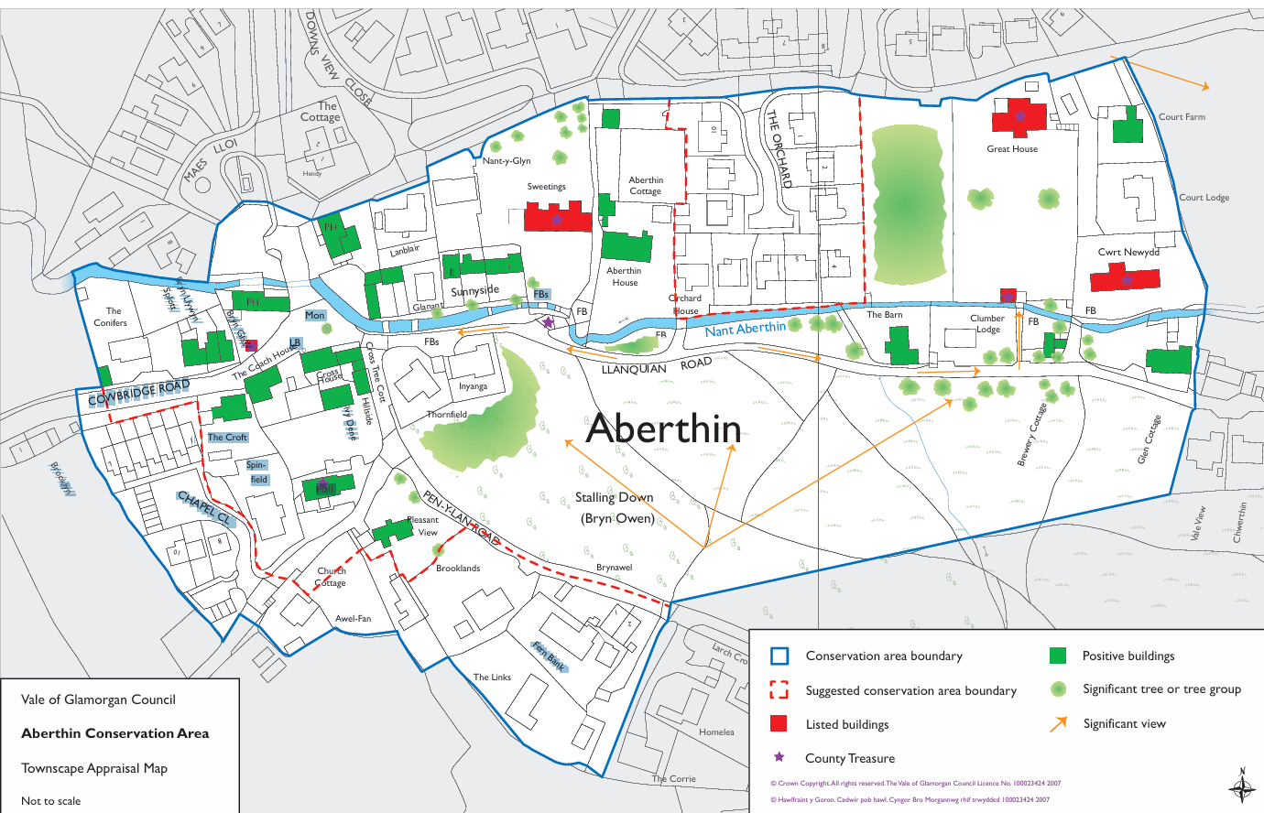
Maes Lloi and site 2299

Conservation Area Management Plan Policy Conflict
The Conservation Area Management Plan emphasises the importance of the surrounding landscape:
“The landscape setting of the Conservation Area is very important and is notable for its rural location at the foot of Stalling Down.”
It further states:
“Development which impacts in a detrimental way upon the immediate setting of the Conservation Area will be resisted.”
and
“The Council will resist applications for change on the edges of the Conservation Area which would have a detrimental effect on the area’s setting.”
Allocating housing on land immediately adjacent to the conservation area therefore creates a direct inconsistency between the RLDP allocation and the Council’s adopted conservation area management guidance.

Flood Risk, Valley Geography and Development Pattern
Aberthin sits on the valley floor of the Nant Aberthin, where fluvial, surface water and groundwater processes interact.
Much of the village lies within Flood Zone 3, with surrounding areas within Flood Zone 2.
The valley floor is also identified by the British Geological Survey as having high susceptibility to groundwater flooding, associated with permeable Carboniferous Limestone classified as a Principal Aquifer and overlying alluvial deposits.
Development in such environments often requires additional space for drainage infrastructure, flood resilience measures and exceedance routes.

Local Development Pattern Reflecting Valley Constraints
Within the historic core of Aberthin, some older buildings are two-storey structures reflecting traditional village development that predates modern flood risk policy and drainage standards.
However, more recent development on the valley floor surrounding the site shows a consistent pattern of single-storey dwellings. This includes Downs View Close to the east, Maes Lloi immediately to the south, and The Acorns bungalow to the north of the site. The newer housing closest to the site is therefore all bungalow development.
This pattern likely reflects the environmental constraints associated with the valley floor, including flood risk, surface water runoff from surrounding slopes and groundwater sensitivity associated with permeable limestone and alluvial deposits. Bungalows typically require larger plots and lower densities, allowing greater flexibility for drainage infrastructure, exceedance routes and flood resilience measures.
If development were to follow this established pattern, the density achievable on the site would likely be lower than the approximately 25 dwellings assumed in the allocation. Conversely, achieving the allocated density through two-storey housing would introduce development that departs from the surrounding valley-floor pattern and would be more visually prominent within the Special Landscape Area and protected views from Stalling Down.

Additional Site Constraints (Summary)
While the focus of this objection concerns landscape and conservation area setting, the site is also affected by additional constraints:
Highway access
Access would rely on narrower rural lanes serving Aberthin, not designed for significant increases in traffic. There are known highway issues including 90 degree bend and previously closed access points (opposite the site).
Infrastructure capacity
Aberthin is a small rural settlement with limited infrastructure capacity, including drainage, sewerage and local services.
Geological conditions
The site lies above permeable limestone classified as a Principal Aquifer, overlain by alluvial valley deposits.
SuDS feasibility
High groundwater susceptibility raises uncertainty regarding the effectiveness of infiltration-based drainage systems.
Hydrological sensitivity
The site lies within the wider hydrological catchment of Cors Aberthin SSSI, meaning drainage changes could affect wetland hydrology.
Risk to surrounding properties
Changes to runoff patterns could potentially increase flood risk affecting existing properties within the village.

Cumulative Constraint Context
Together, these factors demonstrate that the site sits within a concentration of landscape, environmental and infrastructure constraints. While each issue requires separate technical assessment, their combined presence reinforces the sensitivity of the location and raises further questions regarding the consistency of allocating land within the Special Landscape Area and the setting of the Aberthin Conservation Area. In the context of an RLDP that already provides flexibility in housing supply, the allocation of such a constrained site raises legitimate concerns regarding the robustness of the plan’s site selection process.

Closing
In these circumstances, the allocation of Site 2299 appears difficult to reconcile with the Council’s own adopted conservation area management guidance, the purpose of the Special Landscape Area designation, and the landscape protection principles established in Planning Policy Wales, raising serious questions regarding the consistency of the site selection process and the overall soundness of the allocation.

